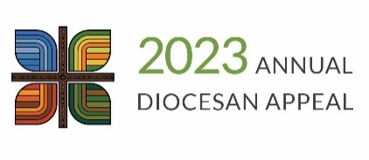

Transmittal Report

Name of person completing this form:

________________________________________

Daytime phone number: ___________________

Email ___________________________________

Date: __________________________

Parish number: __________________

Parish name: ____________________

City/Town: _____________________

|  |  |  |
| --- | --- | --- |
|  | This Report | Total to Date  (not required by Diocese,  for parish records only) |
| 1. Total number of contribution cards enclosed |  |  |
| 2. Total number of checks enclosed |  | $ |
| 3. Total amount of checks enclosed | $ | $ |

Explanation:

Line #1 – Total number of contribution cards enclosed.

Line #2 – Total number of checks enclosed.

Line #3 – Total dollar amount of checks enclosed.

The Total to Date column may be used for your parish records. It is not required by the finance office. The Weekly Detailed Parish Report e-mailed to you will reflect the ongoing total.

Steps to Success:

* Please Do NOT send cash – please issue a parish check for any cash gifts.
* Please Do NOT have donors write credit card numbers on contribution cards. Instead, direct them to dmdiocese.org/giving or have them call the Stewardship Department at 515-237-5083.
* Please place enough postage on your ADA envelopes before mailing so it arrives to the Finance Department in a timely and safe manner.
* Using the transmittal envelopes provided by the Diocese, please mail this weekly transmittal form, signed and completed commitment cards, personal checks and a parish check for any cash gifts to the diocesan finance office.

Diocese of Des Moines

Office of Finance

601 Grand Avenue

Des Moines, Iowa 50309

(515) 237-5028

rwaskel@dmdiocese.org